Blinkit Sales Analysis
Summary
This project analyses Blinkit's retail sales data to understand sales performance, customer preferences, and outlet efficiency. Using Excel, Python, and Power BI, the dataset is cleaned, explored, and visualized to identify key business insights that support data-driven decision-making.

Dataset Documentation
Column | Description
Item Fat Content | Indicates whether the product is Low Fat or Regular Fat.
Item Identifier | Unique identifier assigned to each product.
Item Type | Category of the product (e.g., Dairy, Fruits, Snacks, Frozen Foods).
Outlet Establishment Year | Year in which the outlet was established.
Outlet Identifier | Unique identifier assigned to each outlet/store.
Outlet Location Type | Classification of the outlet's location (Tier 1, Tier 2, Tier 3).
Outlet Size | Physical size of the outlet (Small, Medium, High).
Outlet Type | Type of outlet (e.g., Supermarket Type1, Grocery Store).
Item Visibility | Percentage of display space or visibility allocated to the product within the outlet.
Item Weight | Weight of the product (in kilograms).
Sales | Total sales amount generated by the product. (Target metric for analysis)
Rating | Customer rating given to the product.

Project Objective
To analyse Blinkit's retail sales data and uncover meaningful business insights by evaluating product performance, outlet characteristics, and customer preferences through data analysis and interactive visualizations.
Python – To analyse the dataset
- Created jupyter notebook

- Dataset Size:
  - The Dataset contains 8523 rows across 12 parameters.

- Null Values:
  - In Item Weight there are 1463 null values founded.
    - df['Item Weight'] = df.groupby('Item Identifier')['Item Weight'].transform(lambda x:x.fillna(x.mean()))

- Duplicate Records
  - There are no duplicate entries

- Column Names Standardization
  - Columns names have been standardized as snake_case
    - df.columns = df.columns.str.lower()
    - df.columns = df.columns.str.replace(' ','_')

- Data Types
  - Float value columns have been rounded as 2 decimals after point
    - df[['item_visibility','sales']] = df[['item_visibility','sales']].round(2)

- Categorical columns
  - item_fat_content have 1 double value as Low Fat & low fat (low fat have to transform into Low Fat)
    - df['item_fat_content'] = df['item_fat_content'].str.replace('low fat','Low Fat')

- Create SQL alchemy
  - Imported the SQLalchemy to create engine
  - Updated the datasets into the SQL and created the database.

Analyse through SQL
Lifespan of outlets
Minimum_year | Maximum_year | lifespan
2011 | 2022 | 11

key metrix
Metrix | Value
Total Sales | 12,01,682
Average Sales | 141
Number of Items | 8523
Average Rating | 3.97

Sales by item_fat_content
item_fat_content | total_sales | overall_sales | Proportion
Low Fat | 776320 | 1201682 | 64.60%
Regular | 425362 | 1201682 | 35.40%

orders by item_fat_content
item_fat_content | total_orders | overall_orders | proportion
Low Fat | 5517 | 8523 | 64.73%
Regular | 3006 | 8523 | 35.27%

Top 10 Item types by sales
item_type | total_sales | overall_sales | Proportion
Fruits and Vegetables | 178124 | 1201682 | 14.82%
Snack Foods | 175434 | 1201682 | 14.60%
Household | 135977 | 1201682 | 11.32%
Frozen Foods | 118559 | 1201682 | 9.87%
Dairy | 101276 | 1201682 | 8.43%
Canned | 90707 | 1201682 | 7.55%
Baking Goods | 81894 | 1201682 | 6.81%
Health and Hygiene | 68026 | 1201682 | 5.66%
Meat | 59450 | 1201682 | 4.95%
Soft Drinks | 58514 | 1201682 | 4.87%

Top 10 item types by orders
item_type | total_orders | overall_orders | proportion
Fruits and Vegetables | 1232 | 8523 | 14.46%
Snack Foods | 1200 | 8523 | 14.08%
Household | 910 | 8523 | 10.68%
Frozen Foods | 856 | 8523 | 10.04%
Dairy | 682 | 8523 | 8%
Canned | 649 | 8523 | 7.61%
Baking Goods | 648 | 8523 | 7.60%
Health and Hygiene | 520 | 8523 | 6.10%
Soft Drinks | 445 | 8523 | 5.22%
Meat | 425 | 8523 | 4.99%

outlets by sales
outlet_identifier | total_sales | overall_sales | Proportion
OUT035 | 133104 | 1201683 | 11.08%
OUT046 | 132113 | 1201683 | 10.99%
OUT013 | 131809 | 1201683 | 10.97%
OUT018 | 131478 | 1201683 | 10.94%
OUT045 | 130943 | 1201683 | 10.90%
OUT027 | 130715 | 1201683 | 10.88%
OUT049 | 130477 | 1201683 | 10.86%
OUT017 | 129104 | 1201683 | 10.74%
OUT010 | 78132 | 1201683 | 6.50%
OUT019 | 73808 | 1201683 | 6.14%

Outlets by orders
outlet_identifier | total_orders | overall_orders | proportion
OUT027 | 935 | 8523 | 10.97%
OUT013 | 932 | 8523 | 10.94%
OUT049 | 930 | 8523 | 10.91%
OUT046 | 930 | 8523 | 10.91%
OUT035 | 930 | 8523 | 10.91%
OUT045 | 929 | 8523 | 10.90%
OUT018 | 928 | 8523 | 10.89%
OUT017 | 926 | 8523 | 10.86%
OUT010 | 555 | 8523 | 6.51%
OUT019 | 528 | 8523 | 6.20%

Outlet Location Type by sales
outlet_location_type | total_sales | overall_sales | Proportion
Tier 3 | 472133 | 1201682 | 39.29%
Tier 2 | 393151 | 1201682 | 32.72%
Tier 1 | 336398 | 1201682 | 27.99%

Outlet Location type by orders
outlet_location_type | total_orders | overall_orders | proportion
Tier 3 | 3350 | 8523 | 39.31%
Tier 2 | 2785 | 8523 | 32.68%
Tier 1 | 2388 | 8523 | 28.02%

Outlet Size by Sales
outlet_size | total_sales | overall_sales | Proportion
Medium | 507896 | 1201682 | 42.27%
Small | 444794 | 1201682 | 37.01%
High | 248992 | 1201682 | 20.72%
Outlet Size by Orders
outlet_size | total_orders | overall_orders | proportion
Medium | 3631 | 8523 | 42.60%
Small | 3139 | 8523 | 36.83%
High | 1753 | 8523 | 20.57%

Outlet Type by Orders
outlet_type | total_sales | overall_sales | Proportion
Supermarket Type1 | 787550 | 1201682 | 65.54%
Grocery Store | 151939 | 1201682 | 12.64%
Supermarket Type2 | 131478 | 1201682 | 10.94%
Supermarket Type3 | 130715 | 1201682 | 10.88%

Outlet Type by orders
outlet_type | total_orders | overall_orders | proportion
Supermarket Type1 | 5577 | 8523 | 65.43%
Grocery Store | 1083 | 8523 | 12.71%
Supermarket Type3 | 935 | 8523 | 10.97%
Supermarket Type2 | 928 | 8523 | 10.89%

Trend
Sales
Year | total_sales | overall_sales | Proportion
2011 | 78132 | 1201682 | 6.50%
2012 | 130477 | 1201682 | 10.86%
2014 | 131809 | 1201682 | 10.97%
2015 | 130943 | 1201682 | 10.90%
2016 | 132113 | 1201682 | 10.99%
2017 | 133104 | 1201682 | 11.08%
2018 | 204522 | 1201682 | 17.02%
2020 | 129104 | 1201682 | 10.74%
2022 | 131478 | 1201682 | 10.94%
Orders
Year | total_orders | overall_orders | proportion
2011 | 555 | 8523 | 6.51%
2012 | 930 | 8523 | 10.91%
2014 | 932 | 8523 | 10.94%
2015 | 929 | 8523 | 10.90%
2016 | 930 | 8523 | 10.91%
2017 | 930 | 8523 | 10.91%
2018 | 1463 | 8523 | 17.17%
2020 | 926 | 8523 | 10.86%
2022 | 928 | 8523 | 10.89%

Creating Dashboard
With Power BI we created an interactive dashboard to understand visually
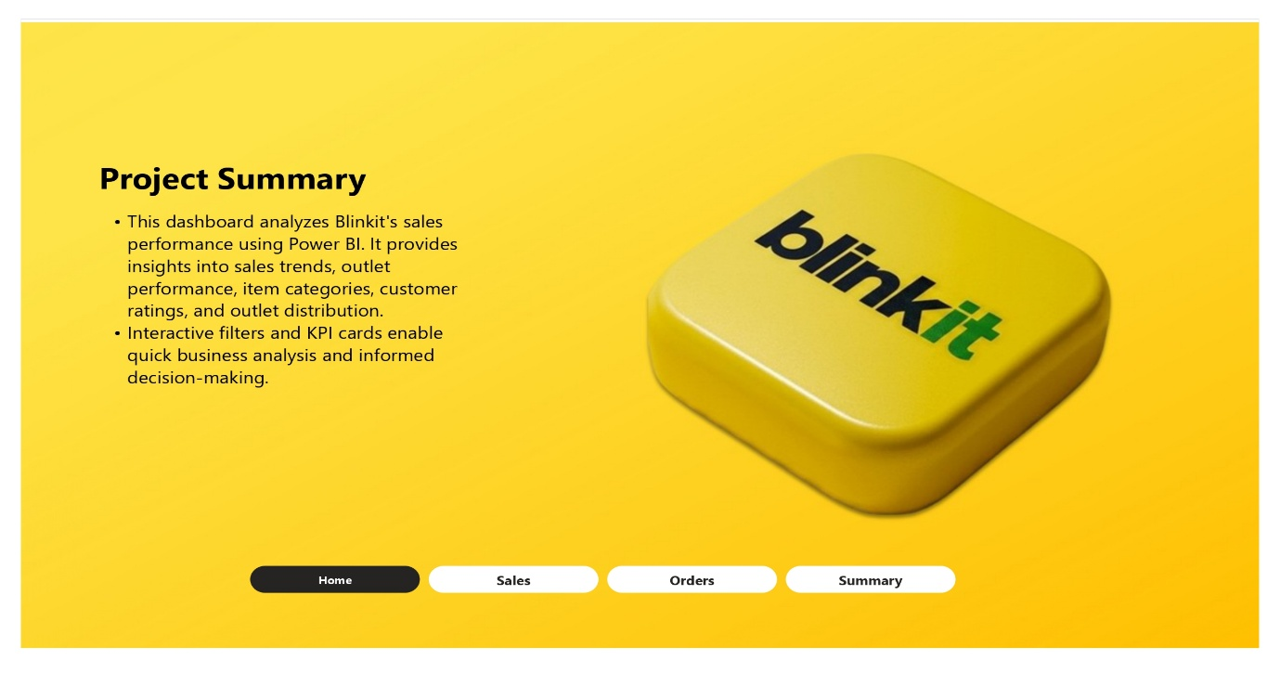
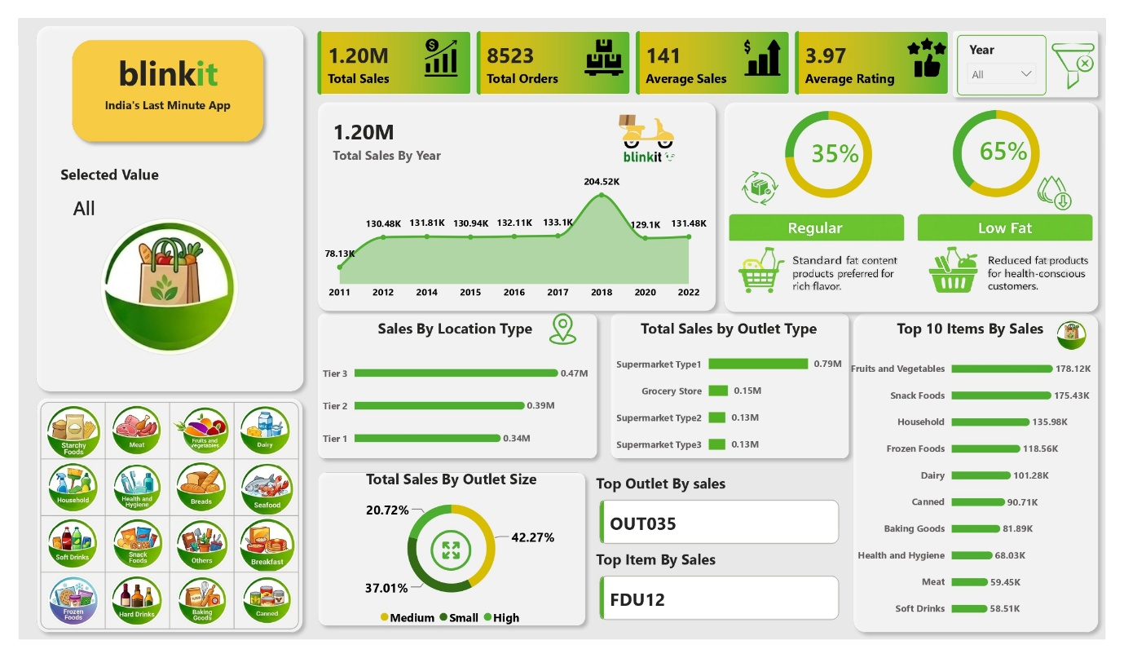
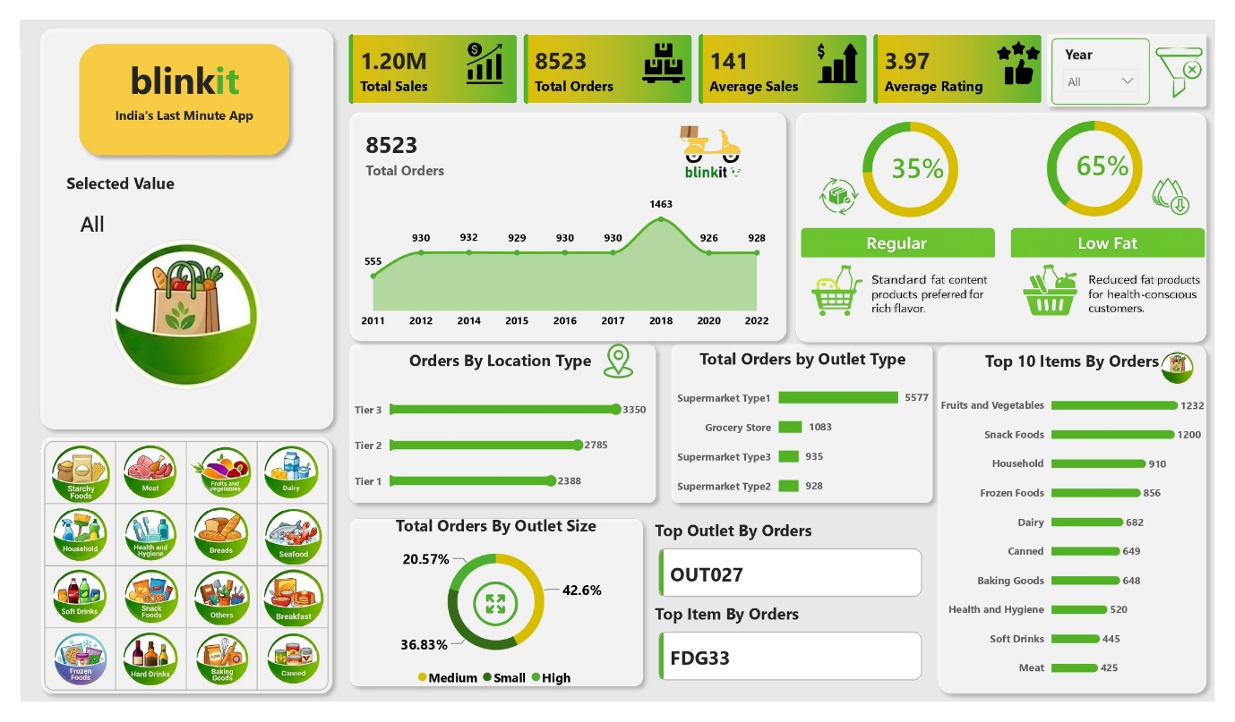

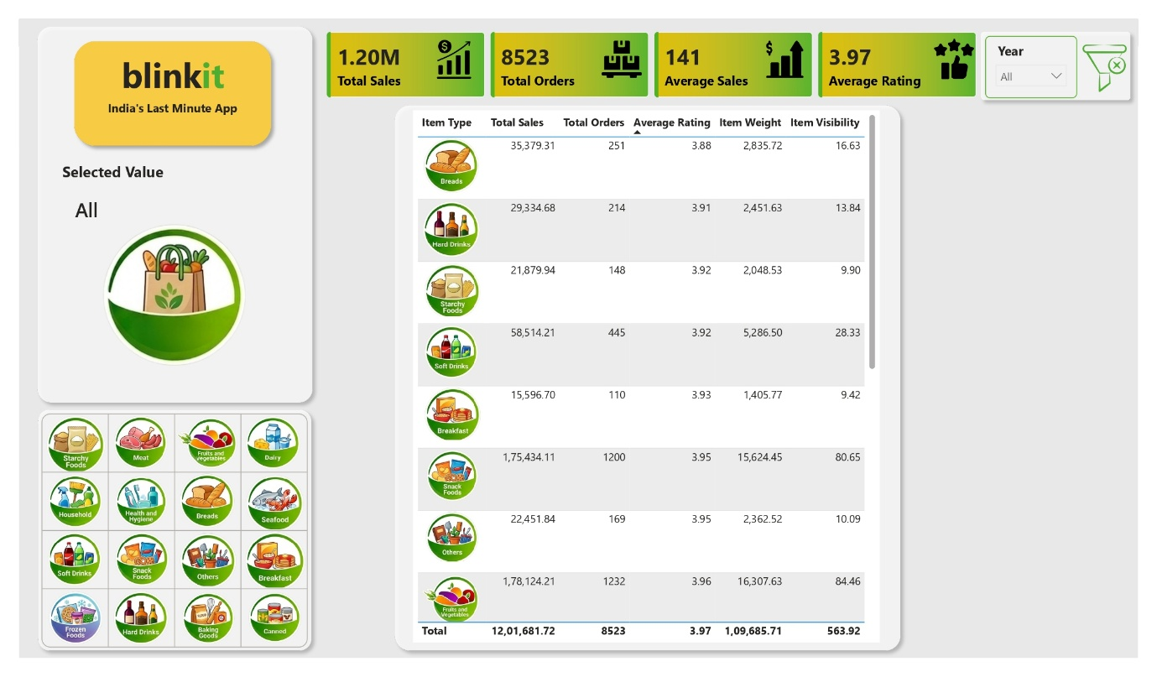

Key Business Insights & Recommendations
1. High Demand for Healthy Products
Low Fat products contribute approximately 65% of both total sales and total orders, indicating a clear customer preference for healthier food options. Blinkit can further strengthen this segment by expanding its Low Fat product portfolio and launching targeted promotional campaigns.

2. Fruits & Vegetables and Snack Foods Drive Revenue
Among all product categories, Fruits & Vegetables and Snack Foods generate the highest sales and order volumes. Maintaining optimal inventory levels and increasing promotional visibility for these categories can further improve overall revenue.

3. Tier 3 Markets Show Strong Business Potential
Tier 3 outlets contribute the highest share of sales compared to Tier 1 and Tier 2 locations. This suggests strong market demand in emerging regions, making Tier 3 cities an ideal focus for future expansion.

4. Medium-Sized Stores Deliver the Best Performance
Medium-sized outlets account for the largest proportion of sales and orders, indicating an efficient balance between operating capacity and customer demand. Future outlet expansion should prioritize this store format.

5. Supermarket Type1 is the Most Successful Outlet Format
Supermarket Type1 contributes nearly two-thirds of overall sales and orders, significantly outperforming other outlet formats. Blinkit should analyze and replicate its product mix, pricing strategy, and operational practices across other outlet types to improve overall business performance.

